**Assignment -4**

Digital Marketing

|  |  |
| --- | --- |
| Student Name | Gopalakrishnan G |
| Student Register Number | 953720106007 |
| College Name | AAA College of Engineering and Technology |

**QUESTION:**

Create email newsletter design using MailChimp or canva tool

**Poster link:**

<https://www.canva.com/design/DAFybwpKf6Q/o2ITeHoXHI_iCc2AND_l7g/edit?utm_content=DAFybwpKf6Q&utm_campaign=designshare&utm_medium=link2&utm_source=sharebutton>

**Poster Title: GGK TRAVELS**

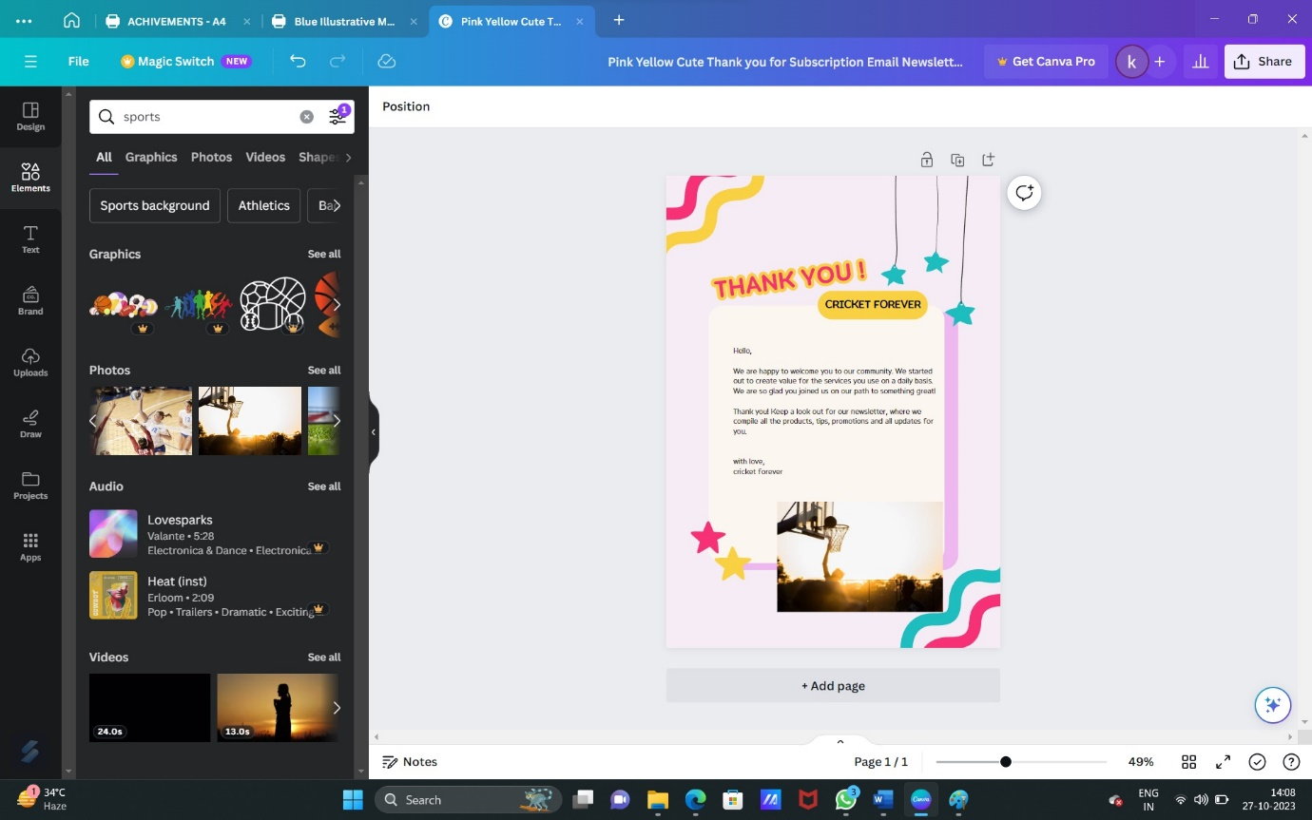

**Poster:**

